RELATIONSHIPS WITHIN FOOD WEBS

All living organisms require energy to grow and reproduce. This energy is provided by their food source - either manufactured (as in green plants) or as complex foods (found and hunted by animals).

The initial source of food in all communities is the green plants - the producers.
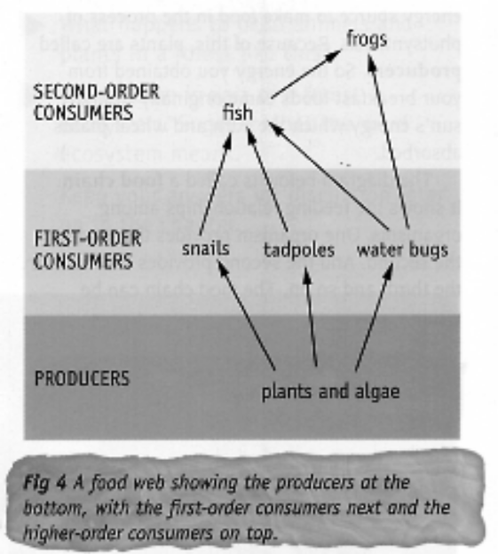
Consumers are those organisms that use (either directly or indirectly) food made by the producers. This includes animals and parasitic plants.

1st order consumers are animals (or plants) that feed on some part of a plant.

e.g. grasshopper, termite.

2nd order consumers (or higher) feed on other smaller animals.

e.g. birds, dingoes.

Food chains are used to show the transfer of energy from one organism to another within a community.

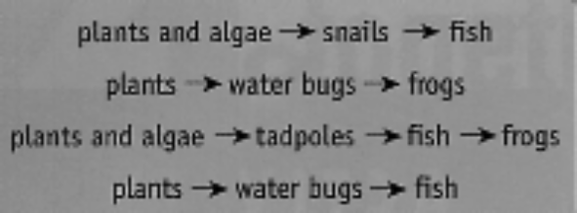

Food webs show all the feeding relationships in a community. They are composed of multiple food chains.

rabbit
crow
dingo
human
wallaby
sheep
grass
eagle

Decomposers are part of all food chains, but are not usually shown. They breakdown complex organic materials into simple substances to be used by the producers.

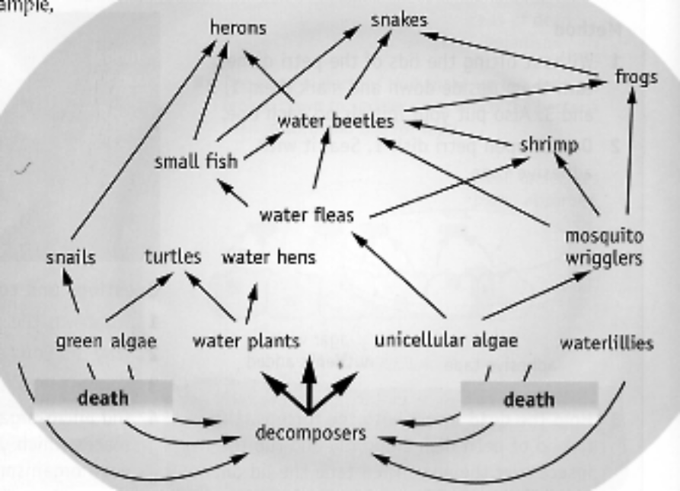

Bacteria and fungi are soil decomposers. They release nitrates and CO₂ that can be used by plants.

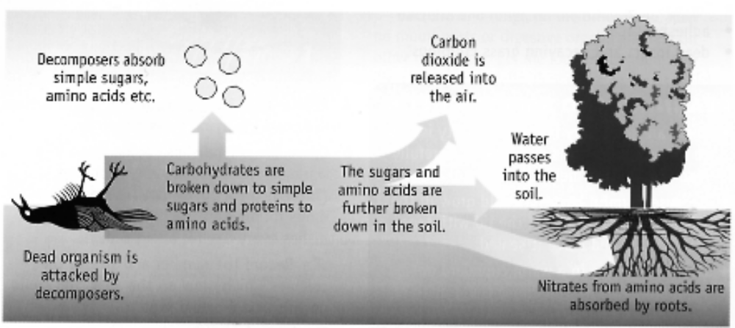

UPSETTING THE BALANCE

An ecosystem needs to be able to maintain a balance so that all species can exist at their optimum population size.

At its simplest, gains due to reproduction and immigration must balance the losses due to death and emigration (leaving).

In any food web, changing one or more condition will affect the number of individuals at all levels.

Example

Consider the following food web for an ecosystem.

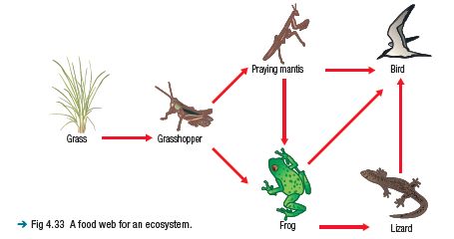

Frogs have decreased in number in parts of Australia for reasons that are still being researched.

If frogs decreased in this ecosystem then the consequences could include:

• an increase in grasshoppers and thus depletion of grass.
• an increase in praying mantises.
• a decrease in lizards.
• a diversion of birds towards a diet of praying mantises rather than
frogs and lizards.
• a consequent decrease in praying mantises.
• a further increase in grasshoppers and intensified depletion of grass.

The most likely outcome is that the bird population will decrease so that all species will return to balance with reduced population sizes. A positive effect is that it might enable the frog population to recover.

